Image Steganography

Bhuvnesh Gangwar

Dept. of Computer Science and Engineerging

Chandigarh University Mohali, India

[19BCS3887@cuchd.in](mailto:19BCS3847@cuchd.in)

Akshat Gupta

Dept. of Computer Science and Engineerging

Chandigarh University Mohali, India

[19BCS3891@cuchd.in](mailto:19BCS3849@cuchd.in)

Aryan Batra

Dept. of Computer Science and Engineerging

Chandigarh University Mohali, India

[19BCS3889@cuchd.in](mailto:19BCS3856@cuchd.in)

Shivam Verma

Dept. of Computer Science and Engineerging

Chandigarh University Mohali, India

[19BCS3886@cuchd.in](mailto:19BCS3855@cuchd.in)

***Abstract***

**Steganography is the art of hiding the fact that communication is taking place, by hiding information in other information. Many different carrier file formats can be used, but digital images are the most popular because of their frequency on the internet. For hiding secret information in images, there exists a large variety of steganography techniques some are more complex than others and all of them have respective strong and weak points. Different applications may require absolute invisibility of the secret information, while others require a large secret message to be hidden. This project report intends to give an overview of image steganography, its uses and techniques. It also attempts to identify the requirements of a good steganography algorithm and briefly reflects on which steganographic techniques are more suitable for which applications.**

1. INTRODUCTION

The word steganography is derived from the Greek words stegos meaning cover and grafia meaning writing defining it as covered writing. Image steganography the information is hidden exclusively in images. Steganography is the art and science of secret communication. It is the practice of encoding/embedding secret information in a manner such that the existence of the information is invisible. The actual files can be referred to as cover text, the cover image, or cover audio message. After inserting the secret message it is referred to as stego- medium. A stego-key has been used for hiding encoding process to restrict detection or extraction of the embedded data .

Watermarking and fingerprinting related to steganography are basically used for intellectual property protection needed. A digital watermark is a kind of marker covertly embedded in a noise-tolerant signal such as audio or image data. It is typically used to identify ownership of the copyright of such signal.

The embedded information in a watermarked object is a signature refers the ownership of the data in order to ensure copyright protection. In fingerprinting, different and specific marks are embedded in the copies of the work that different customers get. In this case, that becomes easy for the property owner to find out such customers who give themselves the right to violate their licensing agreement when they illegally transmit the property to other groups

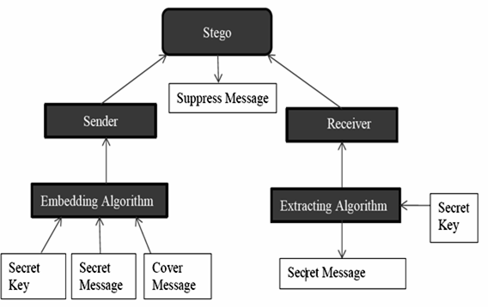

**Figure 1.1** Steganography System Scenarios

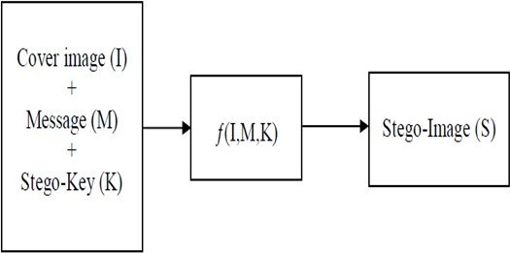

**Figure 1.2** Simple Steganographic Model

*Applications of Steganography*

1. Secret Communications the use steganography does not advertise secret communication and therefore avoids scrutiny of the sender side, message, and recipient. A secret, blueprint, or other sensitive information can be transmitted without alerting potential attackers.
2. Feature Tagging Elements can be embedded inside an image, as the names of individuals in a photo or locations in a map. Copy the stego-image also copies all of the embedded features and only parties who possess the decoding stego-key will be able to extract and view the features.
3. Copyright Protection Copy protection mechanisms that prevent data, generally digital data, from being copied.
4. **SYSTEM MODULE** Steganography hide the messages inside the Cover medium, Many Carrier formats. Breaking of steganography is known as Steganalysis.

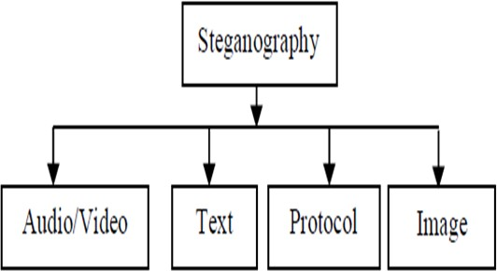

**Figure 1.2** Categories of steganography

The insertion and analysis of water-marks to protect copyrighted material is responsible for the recent rise of interest in digital steganography and data embedding.

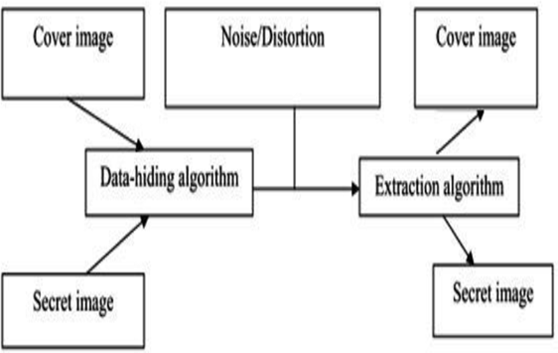

**Figure 1.4** Image Steganography System

*Image Steganalysis*

Steganalysis is the breaking of steganography and is the science of detecting hidden information. The major objective of steganalysis is to break steganography and the detection of stego image. All steganalysis algorithms depend on steganographic algorithms introducing statistical differences between cover and stego image.

*Steganalysis types:*

Visual attacks it discovered the hidden information, that helps to separate the image into bit planes for further more analysis. The statistical attacks Statistical attacks may be passive or active. Passive attacks include identifying presence or absence of a secret message or embedding algorithm used. Active attacks are used to investigate embedded message length or hidden message location or secret key used in embedding. Structural attacks the format of the data files changes as the data to be hidden has been embedded, identifying this characteristic structure changes can help us to find the presence of image/text file.

1. **LITERATURE REVIEW**

In the year of 2013 Soni, A.; Jain, J.; Roshan, R., The Fractional Fourier transform (FrFT), [1] Investigated on as a generalization of the classical Fourier transform, introduced years ago in mathematics literature. The enhanced computation of fractional Fourier transform, the discrete version of FrFT came into existence DFrFT. This study of illustrates the advantage of discrete fractional

Fourier transform (DFrFT) as compared to other transforms for steganography in image processing. The result shows same PSNR in both domain (time and frequency) but DFrFT gives an advantage of additional stego key. The order parameter of this transform.

In the year of 2013 Akhtar, N.; Johri, P.; Khan, S., [2] implemented a variation of plain LSB (Least Significant Bit) algorithm. The stego-image quality has been improved by using bit-inversion technique. LSB method improving the PSNR of stegoimage. Through storing the bit patterns for which LSBs are inverted, image may be obtained correctly. For the improving the robustness of steganography, RC4 algorithm had been implemented to achieve the randomization in hiding message image bits into cover image pixels instead of storing them sequentially. This method randomly disperses the bits of the message in the cover image and thus, harder for unauthorized people to extract the original message. The presented method shows good enhancement to Least Significant Bit technique in consideration to security as well as image quality.

In the year of 2013 Prabakaran, G.; Bhavani, R. and Rajeswari P.S. [3] Investigated on Medical records are extremely sensitive patient information a multi secure and robustness of medical image based steganography scheme is proposed. This methodology provides an efficient and storage security mechanism for the protection of digital medical images. Authors proposed a viable steganography method using Integer Wavelet Transform to protect the MRI medical image into a single container image. The patient's medical diagnosis image has been taken as secret image and Arnold transform was applied and scrambled secret image was obtained. In this case, the scrambled secret image was embedded into the dummy container image and Inverse IWT was taken to get a dummy secret image. It has been observed that the quality parameters are improved with acceptable PSNR compared to the existing algorithms.

In the year of 2012 Thenmozhi, S. and Chandrasekaran, M., presented the novel scheme embeds data in integer wavelet transform coefficients by using a cropping function in an 8×8 block on the cover image. The optimal pixel change process has been applied after embedding the message. Authors employed the frequency domain to increase the robustness of our steganography method. Integer wavelet transform avoid the floating point precision problems of the wavelet filter. Result shows that the method outperforms adaptive steganography technique based on integer wavelet transform in terms of peak signal to noise ratio and capacity.

In the year of 2012 Das, R. and Tuithung, T. proposed a novel technique for image steganography based on Huffman Encoding. Two 8 bit gray level image of size M X N and P X Q are used as cover image and secret image respectively. Huffman Encoding is performed over the secret image/message before embedding and each bit of Huffman code of secret image/message is embedded inside the cover image by altering the least significant bit (LSB) of each of the pixel's intensities of cover image. The size of Huffman encoded bit stream and Huffman Table are also

embedded inside the cover image, in order that the Stego- Image becomes standalone information to the receiver. Results show that the algorithm has a high capacity and a good invisibility. Moreover Peak Signal to Noise Ratio (PSNR) of stego image with cover image shows better result in comparison with other existing steganography approaches. The satisfactory security is maintained in this research.

In the year of 2012 Hemalatha, S, Acharya, U.D. and Renuka presented integer Wavelet Transform (IWT) is used to hide the key thus it is very secure and robust because no one can realize the hidden information and it cannot be lost due to noise or any signal processing operations. Result shows very good Peak Signal to Noise Ratio, which is a measure of security. In this method the secret information is hidden in the middle bit-planes of the integer wavelet coefficients in high frequency sub-bands.

In the 2012 Reddy, H.S.M., Sathisha, N. and Kumari, A.

worked on the steganography is used to hide. Secure Steganography using Hybrid Domain Technique (SSHDT). The cover image of different formats and sizes are considered and resized to dimensions of power of 2. The Daubechies Lifting Wavelet Transforms (LWT) is applied on cover image to generate four sub bands XA, XH, XV and XD. The XD band is considered and divided into two equal blocks say upper and lower for payload embedding. The payload of different formats are considered and resized to dimensions of power of 2. The payload is fragmented into four equal blocks. The Decision Factor Based Manipulation (DFBM) is used to scramble further stego object to improve security to the payload. Dubechies Inverse LWT (ILWT) is applied on XA, XH, XV and XD stego objects to obtain stego image in spatial domain. It has been observed that PSNR and embedding capacity of the proposed algorithm is better compared to the existing algorithm.

With the rapid development of internet and wide application of multimedia technology, people can communicate the digital multimedia information such as digital image, with others conveniently over the internet. In numerous cases, image data, transmitted over a network are expected not to be browsed or processed by illegal receivers. Consequently, the security of digital image has attracted much attention recently and many different methods for image encryption have been proposed, such as

Optical systems are of growing interest for image encryption because of their distinct advantages of processing 2-dimensional complex data in parallel at high speed. In the past, many optical methods have been proposed in . Among them the most widely used and highly successful optical encryption scheme is double random phase encoding proposed in. It can be shown that if these random phases are statistically independent white noise then the encrypted image is also a stationary white noise. In some schemes, chaos based functions are used to generate random phase mask. Such as the generalization of the conventional Fourier transform.

1. **MOTIVATION**

In steganography, the message is embedded into the digital media rather than encrypting it. The digital media contents, called the cover, can be determined by anybody, the message hidden in the cover can be detected by the one having the true key. The message in the message after the receiver gets the data. That allows steganography to protect the embedded information after it is decrypted. Steganography is therefore broader than cryptography.

Signal processing area includes- filtering, de-noising method, interference suppression, radar signal processing, electromagnetic wave propagation, and wireless communication systems. The area of the image processing applications includes steganography, watermarking.

1. OBJECTIVES

The goal of steganography is covert communication. So, a fundamental requirement of this steganography system is that the hider message carried by stego-media should not be sensible to human beings.

The other goad of steganography is to avoid drawing suspicion to the existence of a hidden message. This approach of information hiding technique has recently became important in a number of application area

This project has following objectives:

To product security tool based on steganography techniques.

To explore techniques of hiding data using encryption module

of this project

To extract techniques of getting secret data using decryption module.

Steganography sometimes is used when encryption is not permitted. Or, more commonly, steganography is used to supplement encryption. An encrypted file may still hide information using steganography, so even if the encrypted file is deciphered, the hidden message is not seen

**V.** METHODOLOGY

User needs to run the application. The user has two tab options – encrypt and decrypt. If user select encrypt, application give the screen to select image file, information file and option to save the image file. If user select decrypt, application gives the screen to select only image file and ask path where user want to save the secrete file.

This project has two methods – Encrypt and Decrypt.

In encryption the secrete information is hiding in with any type of image file.

Decryption is getting the secrete information from image file.

1. **CONCLUSIONS**

We have studied for improving the steganalysis performance and also analyzing the hiding capacities of the existing research work. The steganalysis performance of state-of-the-art detectors is near-perfect against current steganographic schemes. A novel, robust and secure hiding schemes that can resist steganalytic detection must be implemented. Hiding schemes are characterized by three complementary requirements- security against steganalysis, robustness beside distortions in the transmission channel, and capacity in terms of the embedded method. This work would be able to be extended for different formats of images.

**REFERENCES**

[1]. Soni, A.; Jain, J.; Roshan, R., "Image steganography using discrete fractional Fourier transform," *Intelligent Systems and Signal Processing (ISSP), 2013 International Conference on* , vol., no., pp.97,100, 1-2 March 2013.

[2]. Akhtar, N.; Johri, P.; Khan, S., "Enhancing the Security and Quality of LSB Based Image Steganography," *Computational Intelligence and Communication Networks (CICN), 2013 5th International Conference on* , vol., no., pp.385,390, 27-29 Sept. 2013.

[3]. Das, R.; Tuithung, T., "A novel steganography method for image based on Huffman Encoding," *Emerging Trends and Applications in Computer Science (NCETACS), 2012 3rd National Conference on* , vol., no., pp.14,18, 30-31 March 2012.

[4]. Hemalatha, S.; Acharya, U.D.; Renuka, A.; Kamath, P.R., "A secure image steganography technique using Integer Wavelet Transform," *Information and Communication Technologies (WICT), 2012 World Congress on* , vol., no., pp.755,758, Oct. 30 2012-Nov. 2 2012.

[5]. Prabakaran, G.; Bhavani, R.; Rajeswari, P.S., "Multi secure and robustness for medical image based steganography scheme," *Circuits, Power and Computing Technologies (ICCPCT), 2013 International Conference on* , vol., no., pp.1188,1193, 20-21 March 2013.

[6]. Thenmozhi, S.; Chandrasekaran, M., "Novel approach for image stenography based on integer wavelet transform," *Computational Intelligence & Computing Research (ICCIC), 2012 IEEE International Conference on* , vol., no., pp.1,5, 18-20 Dec. 2012.

[7]. Reddy, H.S.M.; Sathisha, N.; Kumari, A.; Raja, K.B., "Secure steganography using hybrid domain technique," *Computing Communication & Networking Technologies (ICCCNT), 2012 Third International Conference on* , vol., no., pp.1,11, 26-28 July 2012.

[8]. Masud Karim, S.M.; Rahman, M.S.; Hossain, M.I., "A new approach for LSB based image steganography using secret key," *Computer and Information Technology (ICCIT), 2011 14th International Conference on* , vol., no., pp.286,291, 22-24 Dec. 2011.

***Websites***

Following websites are referring to create this project reports.

* [http://www.google.com](http://www.google.com/)
* [http://www.programmer2programmer.net](http://www.programmer2programmer.net/)
* [http://www.codeproject.com](http://www.codeproject.com/)
* [http://www.asp.net](http://www.asp.net/)
* [http://www.asp123.com](http://www.asp123.com/)
* [http://www.wikipedia.org](http://www.wikipedia.org/)